Annexure 2
COMPARISON OF CREEP COEFFICIENT OF NORMAL, HIGH AND ULTRA HIGH PERFORMANCE CONCRETE

P N Ojha*
National Council for Cement & Building Materials, India*

ABSTRACT

Recently, the use of Ultra-High Performance Concrete (UHPC) has become popular due to the availability and significant variety of the mineral and chemical admixtures. Ultra high performance concrete leads to increase in the load carrying capacity of the columns or piers thereby reducing size of members in building and bridges. In prestressed concrete bridges and multi-storeyed buildings, creep becomes critical. A concrete structure when subjected to sustained load causes progressive strain over time, which is associated with the creep phenomenon. The papers present determination of creep coefficient on concrete cylinder of 100 mm diameter and 200 mm height for UHPC and 150 mm diameter and 300 mm height for normal & high strength concrete. An experimental study was conducted to determine the time induced creep strain using creep rig of capacity 2000 kN. The strength level for UHPC, high strength and normal strength concrete were 153.79 MPa, 100.21 MPa and 45.66 MPa respectively. The experimentally obtained creep coefficients were compared with B-3 Model, FIB model code 2010 and B4 model for the test done upto 180 Days and age at loading was 28 days. The creep coefficients determined using B3 and B4 model are over estimating the values in case of high strength concrete and Ultra High Performance Concrete. The primary reason for over estimation of creep in high strength concrete and Ultra High Performance Concrete using B3 and B4 model can be attributed to chemical volume reduction and self-desiccation along with decrease in pore humidity. The complications noticed in creep prediction while using B3 and B4 model due to attenuating effects of diverse admixtures and reactive additives present in high and ultra-strength concrete. In FIB model code 2010, basic creep concept has been considered. Wherein, basic creep has been modelled using a logarithm function, which is infinite ongoing deformation while drying creep approaches a finite value.

Key Words: Creep Coefficient, High Strength Concrete, Ultra High Performance Concrete & Model.

- Introduction

Concrete as a material is time dependent in nature. In particular, concrete creeps under sustained load and shrinks due to the changes in the moisture content of the surrounding environment. These physical changes increase by time. The information on creep and shrinkage of concrete is important to determine the prestressing losses, long term deformations and cracking of the civil engineering structures. Creep performance is a key index in long-term properties of concrete, and the linear compressive creep deformation can reach one to four times of short term elastic compressive deformation [1]. Therefore, the creep behaviour must be considered in the design of concrete structures in order to provide desired safety and serviceability. For the important engineering structures, creep testing of specimen, which is made from the same concrete used in the structures, is the most accurate and reliable technique for determining creep response [2].

2.0 Experimental work
The Physical and Chemical Properties are tabulated in Table-2. Particles of cement were in range of 1.37 to 175 microns. Particle size distribution is shown in figure 1.

3.0. Results and Discussions

Table 1
Physical and Chemical Characteristics of Cementitious Materials

Characteristics | OPC -53 Grade | Silica Fume | Fly Ash | GGBS
Physical Tests:
Fineness (m²/kg) | 320.00 | 22000 | 403 | 400
Soundness Autoclave (%) | 00.05 | - | - | -

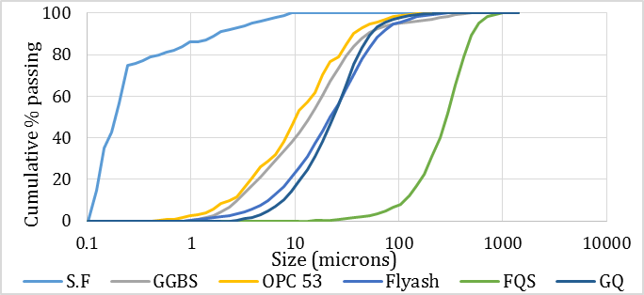

Fig-1: Particle size distribution of materials
4.0 Conclusions

5.0 Acknowledgement

The authors acknowledge that this study is supported by ……………..

6.0 References

- Wenzhong Z. and Can T. (2015). “Study on the effect of the strength grade on the creep behaviour of concrete”. The open Civil Engineering Journal, Vol. 9, pp. 881-887.
- Neville A.M. (1970). “Creep of Concrete: Plain, Reinforced and Pre-stressed”. Amsterdam: North Holland Publishing Co.
- Collepardi, S., Coppola, L., Troli, R., & Collepardi, M. (1997). Mechanical properties of modified reactive powder concrete. American Concrete Institute, SP-173-01(p.22)
- ACI Committee 211.1-1991. “Standard Practice for Selecting Proportions for Normal, Heavyweight and Mass Concrete”. American Concrete Institute, Detroit.
- TC-242-MDC (2014). “TC-242-MDC multi-decade creep and shrinkage of concrete: material model and structural analysis”. RILEM Technical Committee.

