NATIONAL AWARD FOR
ENVIRONMENTAL EXCELLENCE IN
INDIAN CEMENT INDUSTRY

2019 – 2022

QUESTIONNAIRE

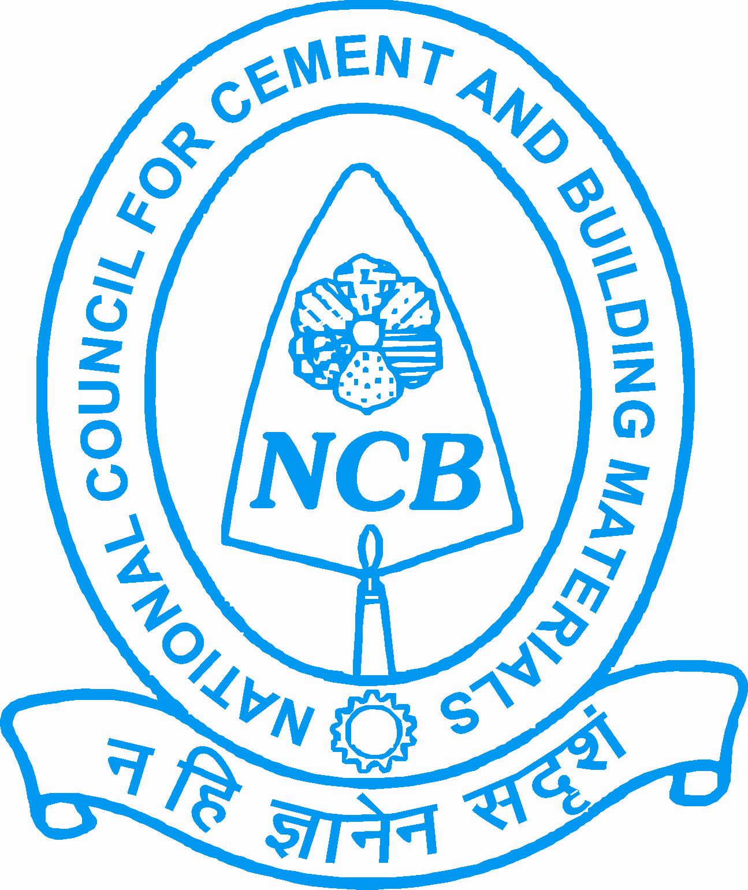

NATIONAL COUNCIL FOR CEMENT AND BUILDING MATERIALS

NATIONAL AWARD FOR ENVIRONMENTAL EXCELLENCE
IN INDIAN CEMENT INDUSTRY

- Introduction
  - The National Council for Cement and Building Materials (NCB) has instituted a scheme of National Awards for Environmental Excellence in the Indian Cement Industry separately to be presented biennially to the units achieving the best performance during the years.

- Objective
  - The objective of the “National Award for Environmental Excellence” for cement plant is to motivate competitive improvement in their performance and to create environment consciousness in the Indian Cement Industry by giving them national recognition to the effort for clean and better environment.

- The Award
There will be five number of awards (1st, 2nd, 3rd and two consolation prizes) combined for the years 2019-2022. Certificate of Participation to be given to all participants.

- Eligibility
  - All Cement manufacturing units in India in production on or before 1st April 2019 will be eligible for environmental excellence awards.

- Last Date of Receiving Entries
31st August 2022

- Reference Year for Award
2019-2022

- The Award Committee
  - For deciding the above awards, the Award Committee is constituted of eminent persons from various organizations/ministry departments including Ministry of Commerce & Industry, Bureau of Indian Standards, Bureau of Energy Efficiency (Ministry of Power), Ministry of Environment, Forests & Climate Change, National Productivity Council, Quality Council of India and National Council for Cement and Building Materials.

- Procedure
  - The participating units will furnish all information in the prescribed questionnaire attached. No point should be left blank. Please provide all answer, otherwise it will be negative marking.
  - The Award Committee will finally decide and declare the award, which shall be binding on the parties concerned.
  - The Award Committee members or their nominees may visit participating units for verification of data supplied, if felt necessary and it will be obligatory on the part of the participating units to provide necessary clarifications.
  - NCB reserves the right for using the data so collected for Research and Development purposes for the benefit of the industry.
  - The Shortlisted Participating unit after evaluation, may be asked to give presentation in pre-defined format before the Award Committee.
  - The name of the participating unit should not be mentioned anywhere in the Questionnaire including the annexures/enclosures attached, except on page intended for General Information.
  - If sufficient space is not available in the format, annexure may be provided for any item.
  - Any anomalous/abnormal data filled in the questionnaire will not be considered for the evaluation.
  - Any data filled in the questionnaire should be supported with evidence such as environment monitoring reports received from the third party or any other relevant records.

- Submission of Nominations
  - A fee of Rs 10,000/- + GST (Rupees Ten Thousand only plus applicable GST) is payable preferably online (as per the attached bank details) favouring “National Council for Cement and Building Materials” for applying for Environment Excellence award. The online payment transaction details are to be provided along with the filled questionnaire.
For applying for the other three award categories – i) Total Quality Excellence, ii) Energy Excellence and iii) Achieving Circular Economy awards, the amount payable will be Rs. 10,000/- + GST (Rupees Ten Thousand only + GST) for each award category.
  - The participants must provide their organization’s GST number with the questionnaire.
  - Copy of the company’s sustainability report for the reference year should be sent along with the questionnaire.
  - Duly filled-in questionnaire along with above enclosures and the online transaction details for payment of fee should be sent at the following address, clearly marking “National Award for Environment Excellence” in bold letters on the envelope.
National Council for Cement and Building Materials
34 km Stone, Delhi-Mathura Road (NH-2)
Ballabgarh – 121004 (Haryana)
E-mail: ncb.awards@ncbindia.com

National Award for Environment Excellence in Indian Cement Industry

Code
(to be filled in by NCB)
QUESTIONNAIRE FOR SUBMITTING DATA / INFORMATION
GENERAL INFORMATION

A. Name of the Unit

B. Address

Pin:

C. GST No. of the Plant

D. Name of the person with whom to correspond for any further clarification,
if required.

Name: Designation:
Tel. : | E-mail:

E. Sustainability Report for reference year attached Yes No

F. Copy of Certificate of Compliance of Pollution Control Yes No
attached

DECLARATION BY CHIEF EXECUTIVE

This is to certify that the data provided in questionnaire for National Award for Environment Excellence in the Indian Cement Industry for the year 2019-22 is true and correct to the best of my knowledge and belief.

Name: Signature
Designation:
Organization Seal:
Date:

