NATIONAL AWARD FOR
ENVIRONMENTAL EXCELLENCE IN
INDIAN CEMENT INDUSTRY
PLANT OPERATION AND LIMESTONE MINES

2015 – 16

QUESTIONNAIRE

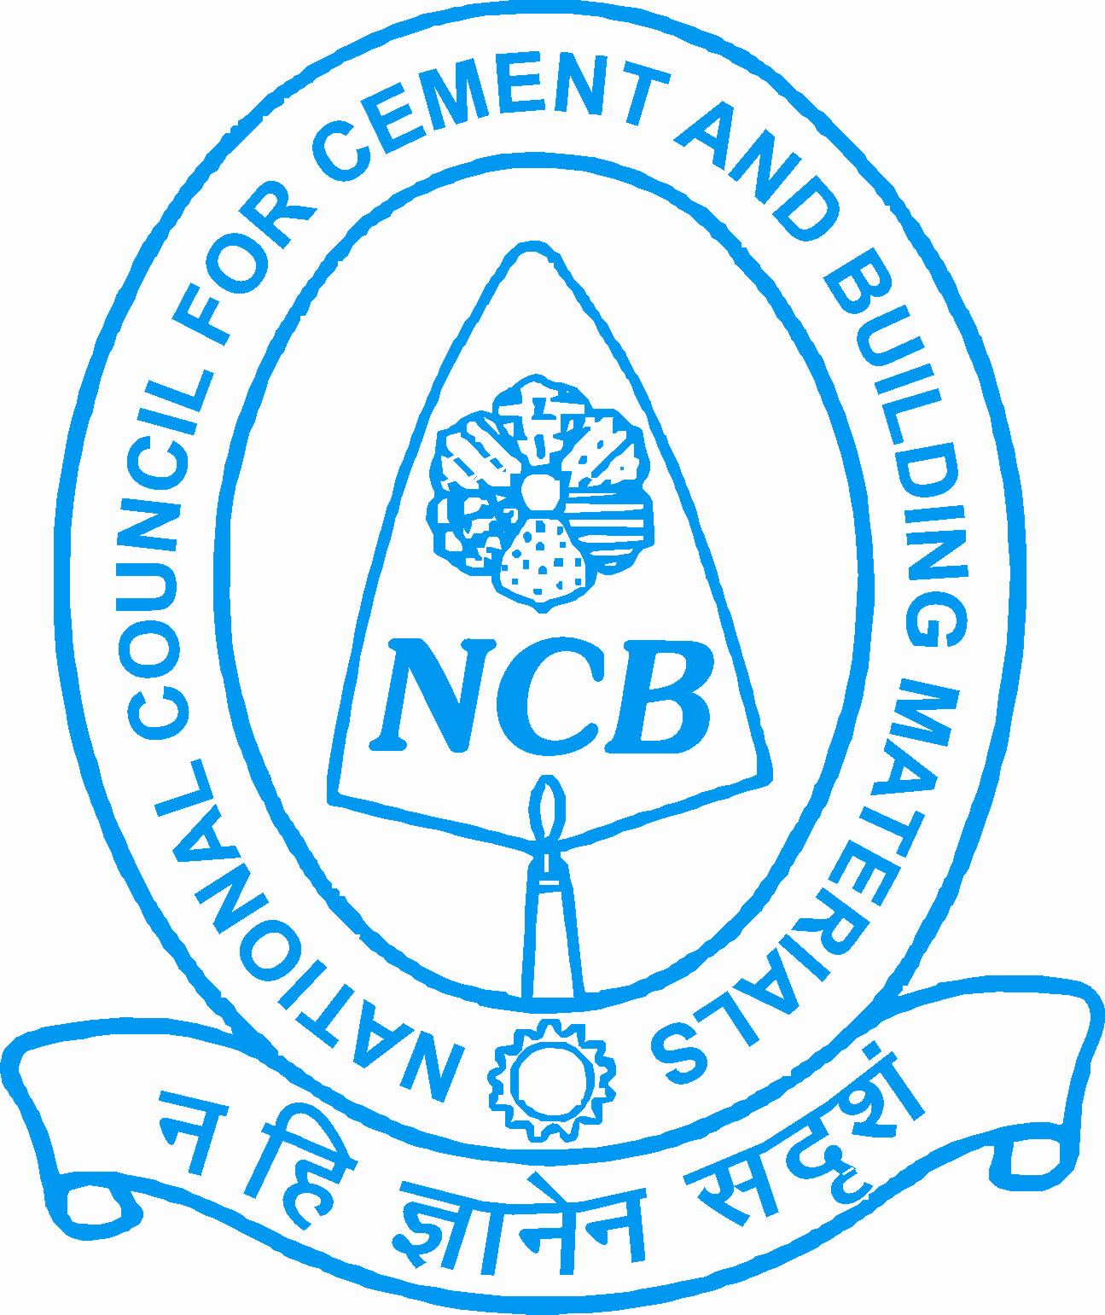

NATIONAL COUNCIL FOR CEMENT AND BUILDING MATERIALS

NATIONAL AWARD FOR ENVIRONMENTAL EXCELLENCE
IN INDIAN CEMENT INDUSTRY AND THEIR LIMESTONE MINES

- Introduction

  - The National Council for Cement and Building Materials (NCB) has instituted a scheme of National Awards for Environmental Excellence in the Indian Cement Industry and their Limestone Mines separately to be presented every year to the units achieving the best performance during the year.

- Objective

  - The objective of the “National Award for Environmental Excellence” for cement plant and their limestone mines is to motivate competitive improvement in their performance and to create environment consciousness in the Indian Cement Industry by giving them national recognition to the effort for clean and better environment.

- The Award

  - The number of the awards to be given each year shall be decided by NCB. Each award will be accompanied with a citation.

  - The awards would be based on two categories:

- National Award for Environmental Excellence in Plant Operation

- National Award for Environmental Excellence in Limestone Mine
Operation

4.0 Eligibility

All Cement manufacturing units in India in production on or before 31st March 2013 will be eligible for environmental excellence awards.

5.0 Last Date of Receiving Entries:

31 July 2017

6.0 The Award Committee
For deciding the above awards, the award committee is constituted of eminent persons from various organizations/ministry departments like MoEF, BEE, QCI, Planning commission, NPC, BIS etc.

7.0 Procedure

  - The participating units will furnish all information in the prescribed questionnaire attached. No point should be left blank. Please provide all answer, otherwise it will be negative marking.
  - The award committee will finally decide and declare the award, which shall be binding on the parties concerned.
  - The Award Committee members or their nominees may visit participating units for verification of data supplied, if felt necessary and it will be obligatory on the part of the participating units to provide necessary clarifications.
  - NCB reserves the right for using the data so collected for Research and Development purposes for the benefit of the industry.
  - The participating units may, at the discretion of the Award Committee, be asked to present their Environmental Excellence Strategy.
  - The name of the participating unit should not be mentioned anywhere in the questionnaire including the annexure/enclosures attached except in PageNo1
  - If sufficient space is not available in the format, annexure may be provided for any item.

8.0 Submission of Nominations

  - A fee of Rs 27, 000/- (Rupees Twenty seven thousand) only per unit is payable for all the three awards i) Energy Efficiency ii) Environmental Excellence both for plants and mines iii) Quality Excellence awards. However, if the entry is for only one category the amount payable shall be Rs 10,000/- (Rupees Ten thousand) only.
8.2 Copies of the following documents which are essential requirements for eligibility for the awards should be sent along with the questionnaire:
- Copy of valid Air & Water Consents from respective SPCB.
- Copy of Environmental statement last submitted to SPCB.
- Copy of certificate from IBM regarding duly approved Mine Plan.
- Status of Implementation of CREP.
- Last Copy of EIA/EMP study carried out for plant, mines and captive power plant.
- If any other Environmental Management tool is used for environmental improvement of plant & mine.
8.3 If your company is ISO14001, OHSAS 18001 certified, please give names of auditing firm and certifying agency and its validity period.
8.4 If there is any complaint from the public in last three years regarding pollution due to your unit, please give its details and action taken for its redressal.
8.5 Kindly provide a certificate by CEO of your plant that your organization has no legal proceedings pending in any court due to breach of environmental law either for Cement plant or Limestone mine.
8.5 Duly filled in questionnaire along with all relevant enclosures should be sent at following address marking clearly in bold letter “NATIONAL ENVIRONMENTAL AWARD SCHEME” on the envelope, National Council for Cement and Building Materials, 34 Km Stone, Delhi-Mathura Road (NH-2), Ballabgarh – 121004 (Haryana).

